Neon Rush GDD

No Sleep Alpha Team

Mark Miller - 101002069 - Mark-Miller04@outlook.com

Jacob Thrasher - 101009388 - its_thrasher@live.ca

Andrew MacMillan - 100992185 – andrewwm96@gmail.com

# Description

“Neon Rush” is an upcoming title developed by No Sleep Alpha Team for Android mobile devices. It is a 2D top down game with an emphasis on colour effecting gameplay. The player is white by default, but all obstacles and enemies in the game are different neon colours, which impacts the player’s mobility in different ways as well as being bright and visually appealing. The player can change colour for a brief time to escape enemies and survive longer. This promotes quick thinking and skilled gameplay.

The UI will be very simple and unobtrusive. Visual appeal is designed to be at the forefront of the experience, and only minimal UI will sit in front of it. The score will appear as a small counter in one corner of the screen to track the player’s progress. The only other UI will be an unobtrusive indicator on the edge of the screen that guides the player to the next objective point. The player’s score is incremented every second the player is alive. As they navigate the level the player will reach objective points that increase the rate of point accumulation, and the physical size of the ball. This increased score payout is offset by making it more difficult to navigate around obstacles due to having to move a larger ball, and by having a larger target for enemies to collide with the player.

# Screen Layout

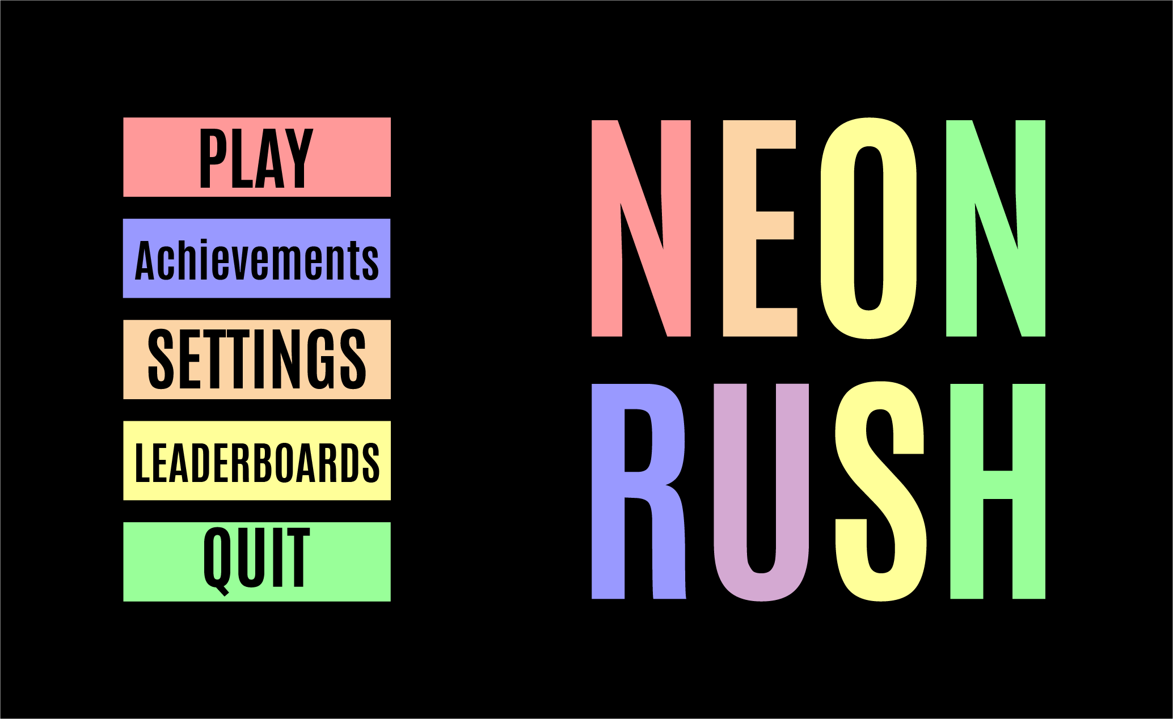

Main Menu

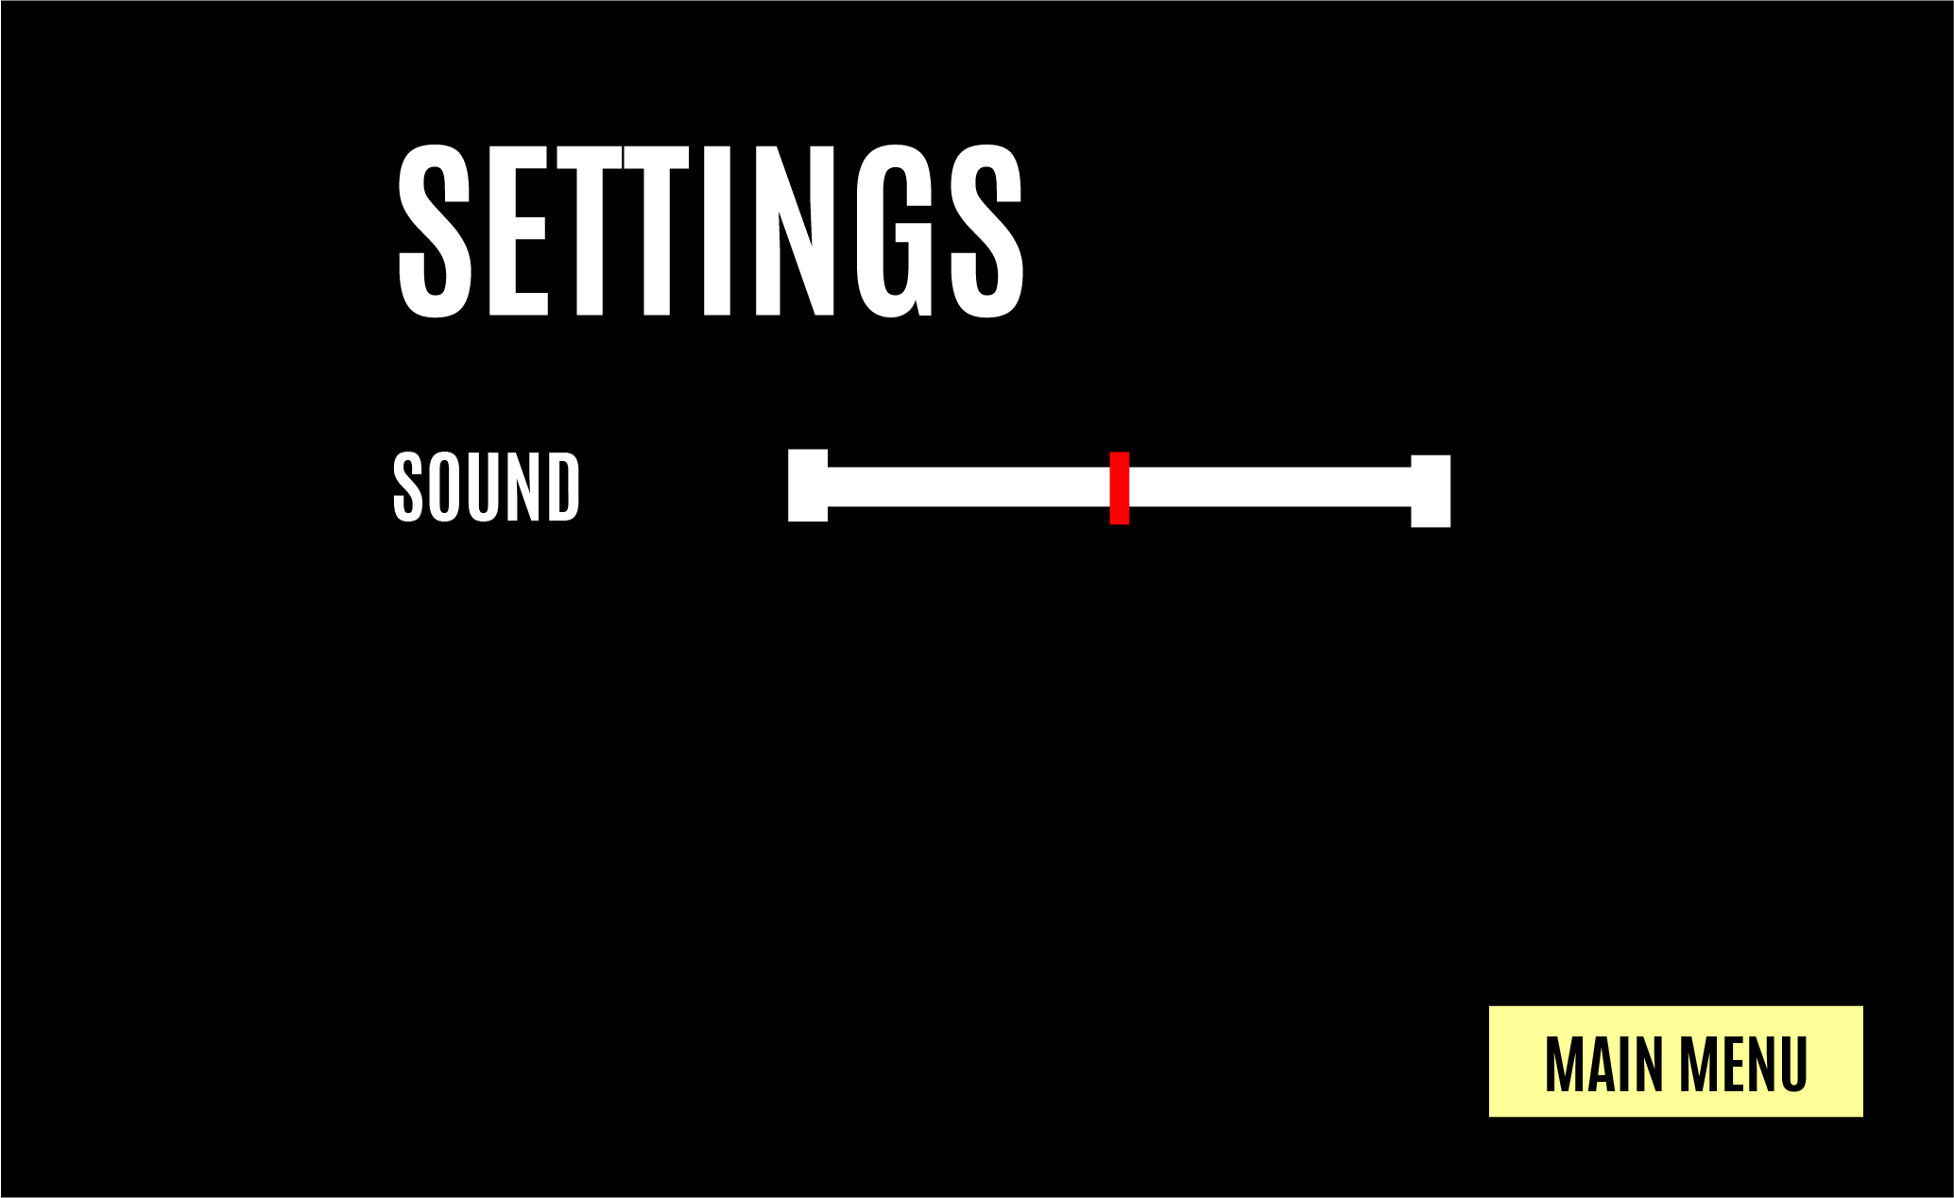

Settings Menu

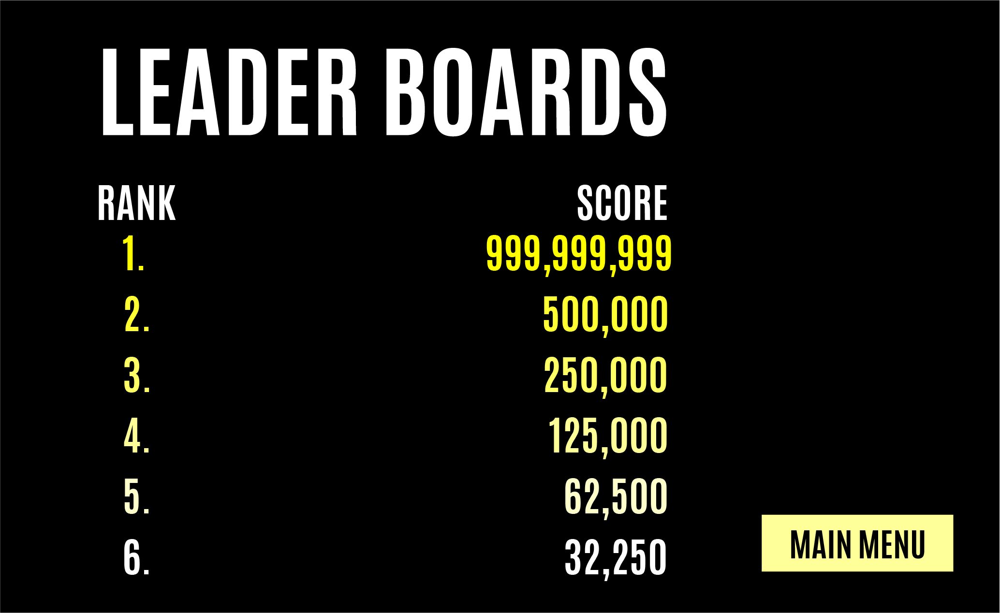

Leader Boards

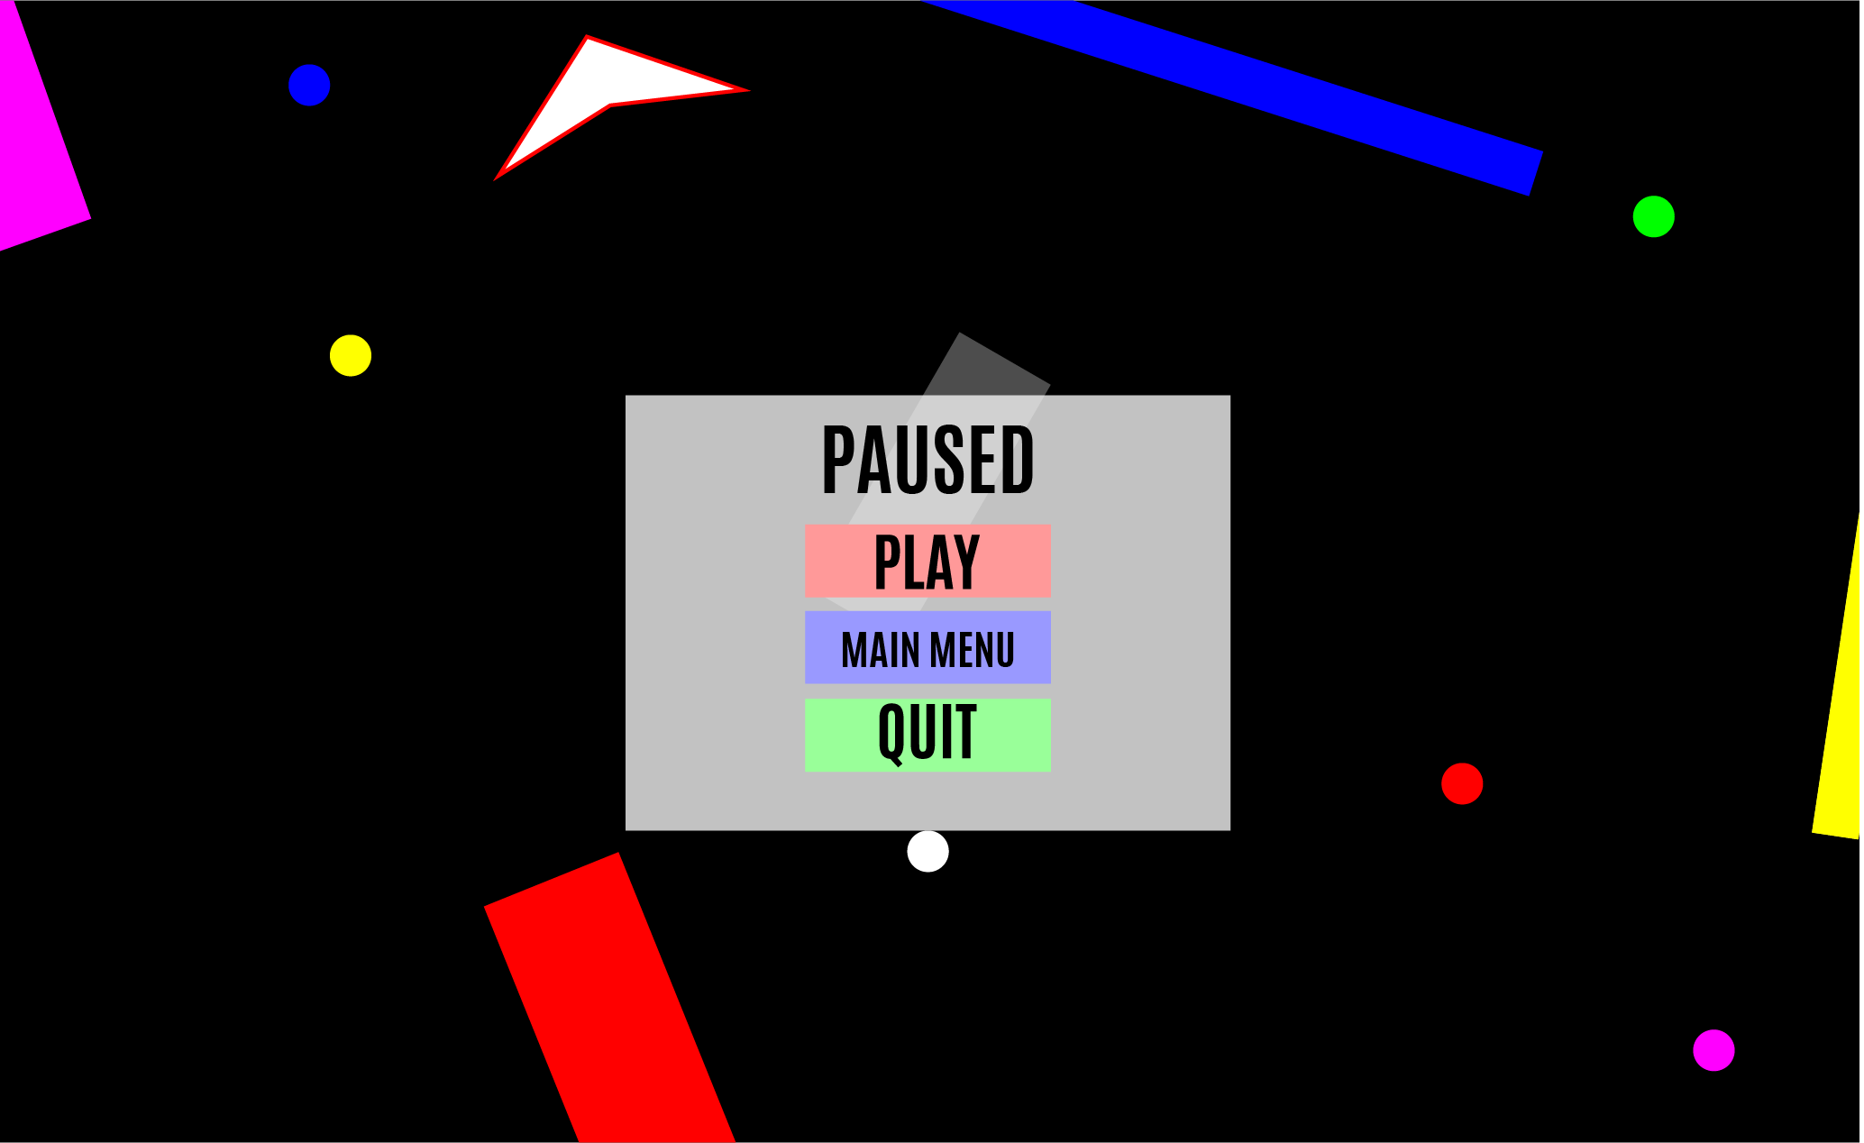

Pause Screen

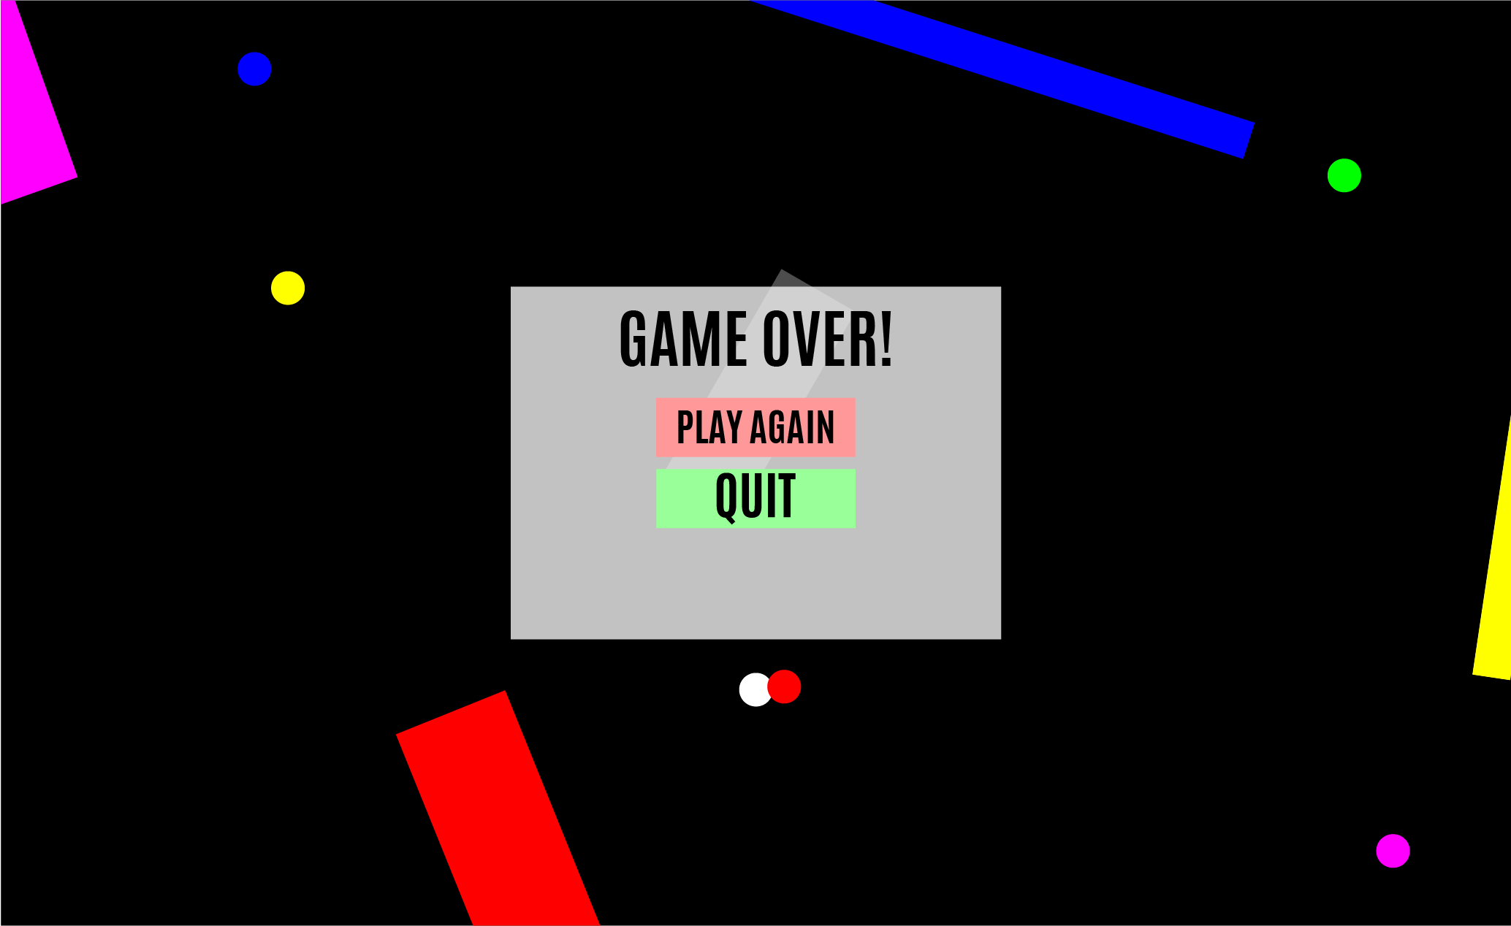

Game Over Screen

# Screen Flow Diagram

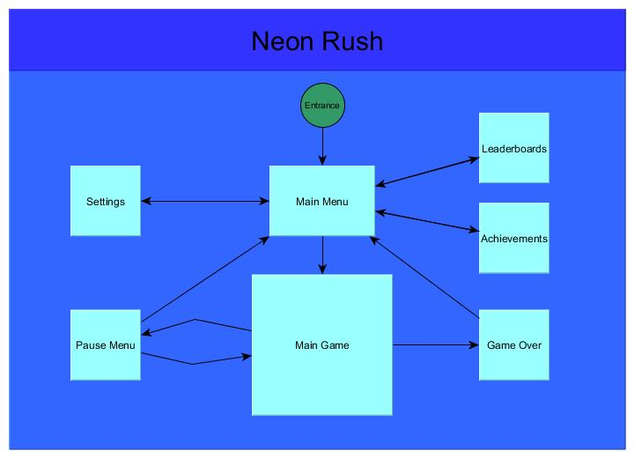

# Assets

Primitive shapes? Art is super minimal

# Backstory

In a world of colour, you were created colourless. You didn’t ask for this; but it’s too late the damage has been done and now everything in your world wants to reclaim you. Survive as long as you can in a world that wants you gone.

# Game Mechanics

The player controls a ball using the device’s accelerometer (tilt controls), and must attempt to survive for as long as possible in a highly dynamic, randomly generated obstacle course. By default the player cannot pass through obstacles of different colours than themselves, and must navigate around them to dodge enemies and reach objective points. Powerups of different colours are scattered throughout the level at random, and once collected can be used to temporarily change the colour of the ball. When the colour of the ball matches the colour of the obstacle, the ball can pass through. The enemies are also coloured using the same palette, and abide by the same navigation rules as the player, meaning enemies can pass through obstacles that match their colour.

If the player collides with an enemy the game is over, unless they match the colour of the enemy, in which case the enemy is removed from the game. Colour change is temporary however, and the player reverts to the default white after a short period of time. Objective points appear inside the course to give the player goals to reach within the level, and each point reached boosts both the difficulty, and the rate at which score increases. When the player inevitably gets hit by an enemy their score is recorded in a leaderboard, promoting high score chasing, competition, and replay value.

Achievements and aesthetic unlocks are tied to achieving high score benchmarks, and performing certain feats in game. As the player approaches their previous best score the colour of the UI will transition from white to gold, with a flash signifying they beat the record. As colour palette powerups are collected, up to three will be displayed on one side of the screen as small UI buttons. Pressing any of them will activate the colour swap on the ball.

The indicator will move about the edge of the screen much like a waypoint does in most traditional minimap designs, directing the player in real time towards the objective. The player’s score is incremented every second the player is alive. and the physical size of the ball.

# Sketch of Level

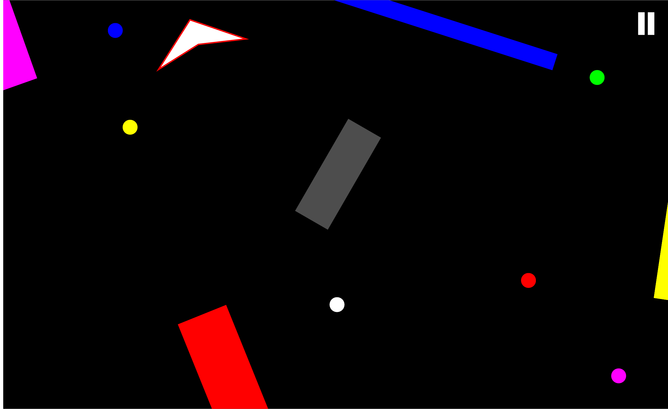

Gameplay Screen